**EXP 14** Create a Snapshot of a VM and Test it by loading the Previous Version/Cloned VM

**PROCEDURE:**

**STEP 1** Install VM ware software

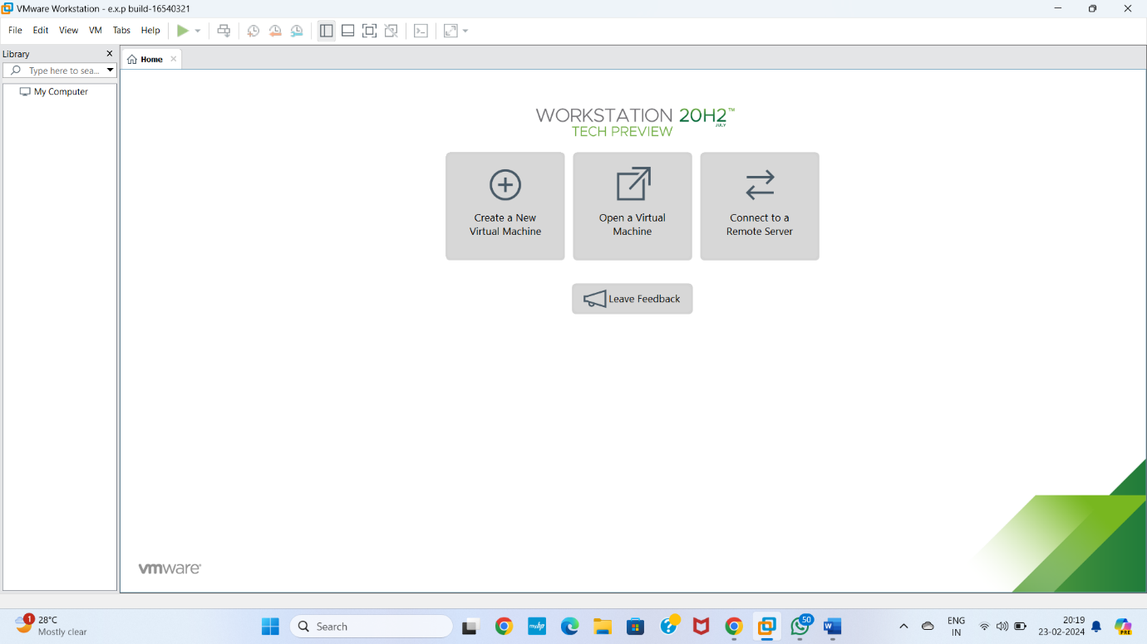

**Step 2** CREAT A NEW VIRTUAL MACHINE GIVE NEXT

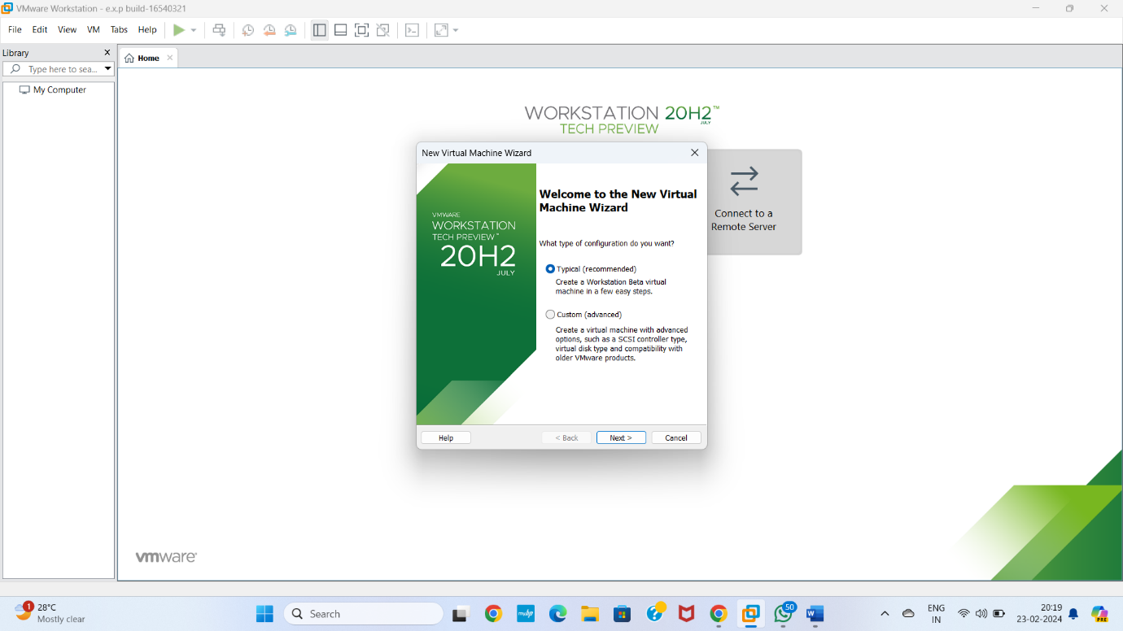

**STEP 3** Select I will install operating system later Give next

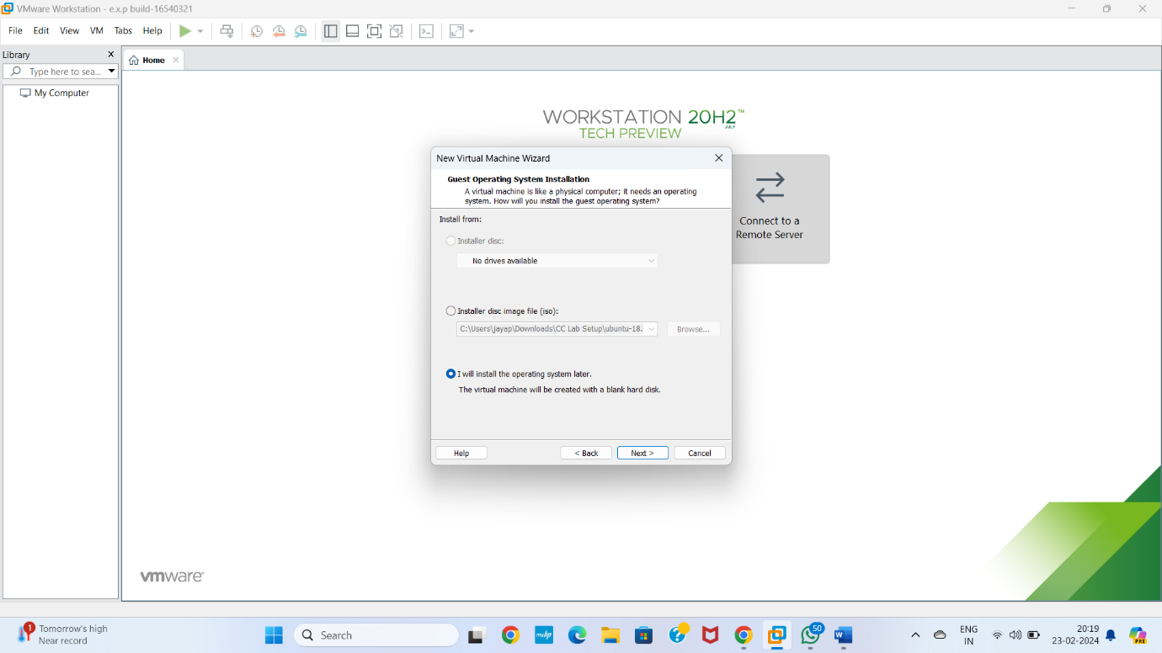

**STEP 4** Select gust operating system Give next

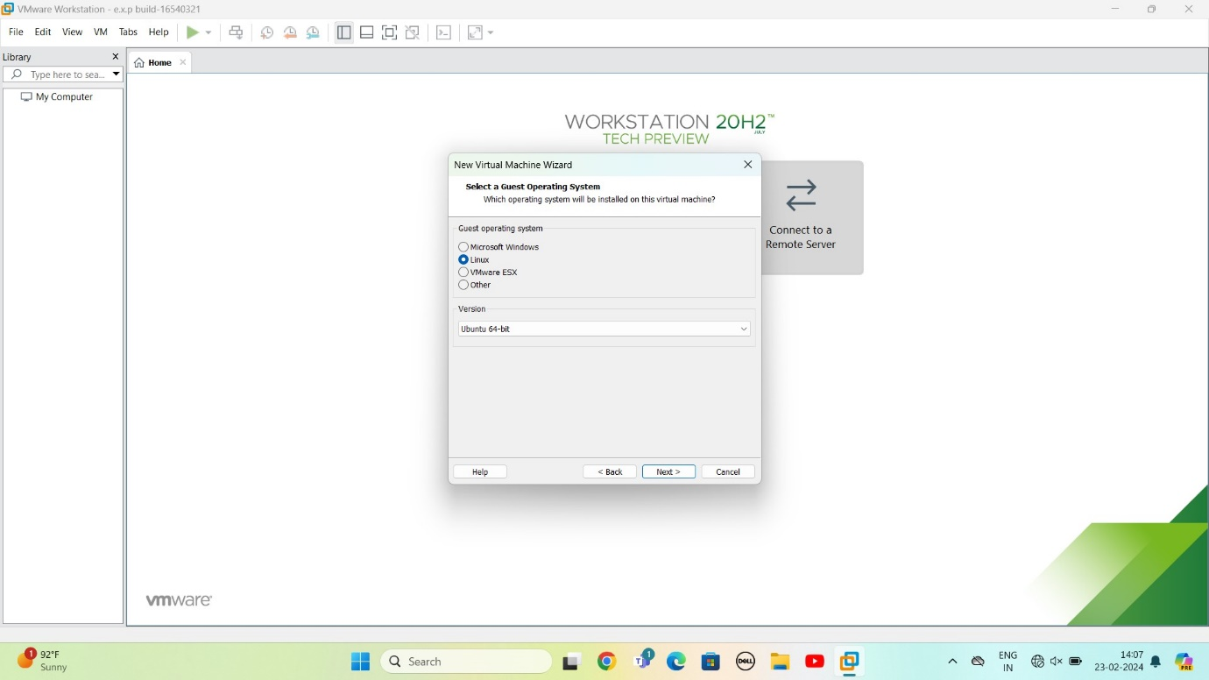

**STEP 5** selects name of virtual machine Give next

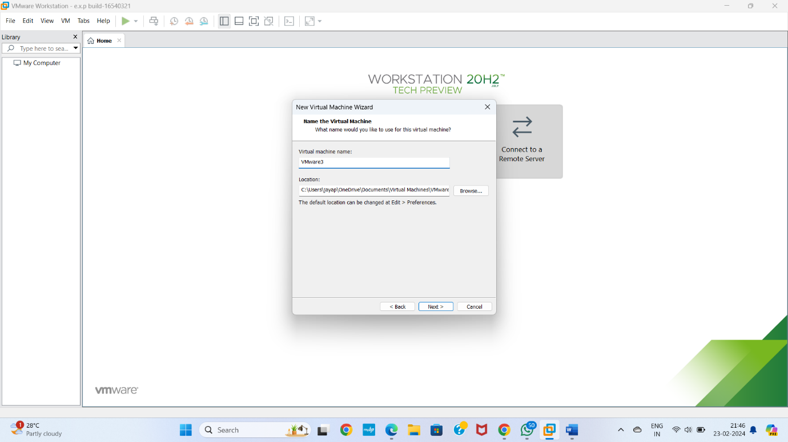

**STEP 6** Select the data storing disk and maximum size of disk Give next

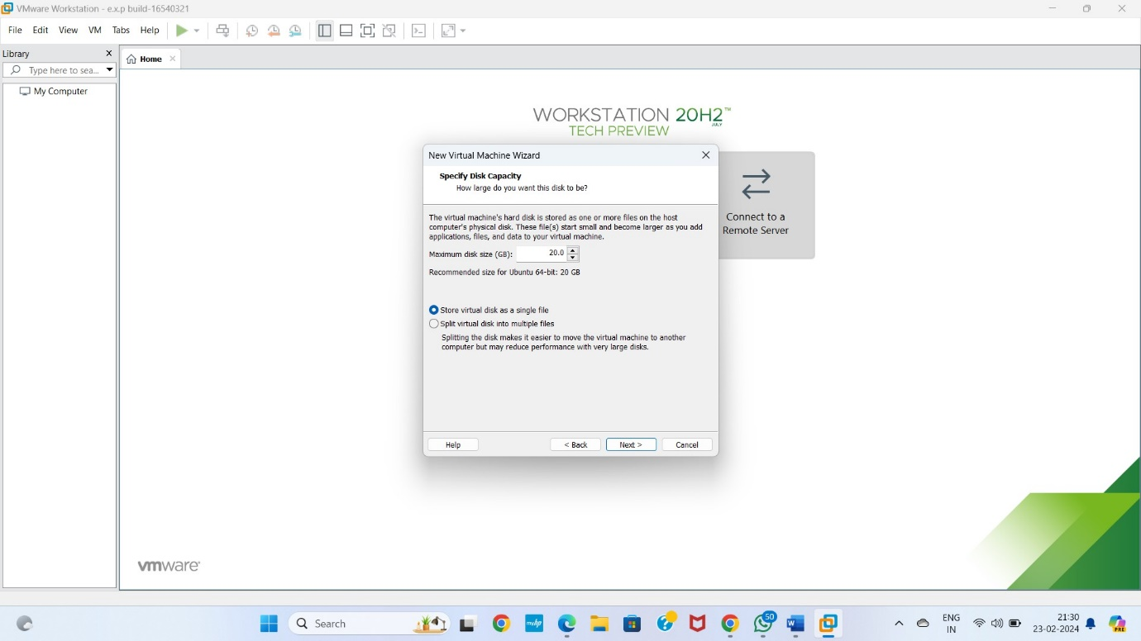

**STEP 7** Ready to create virtual machine Give finish

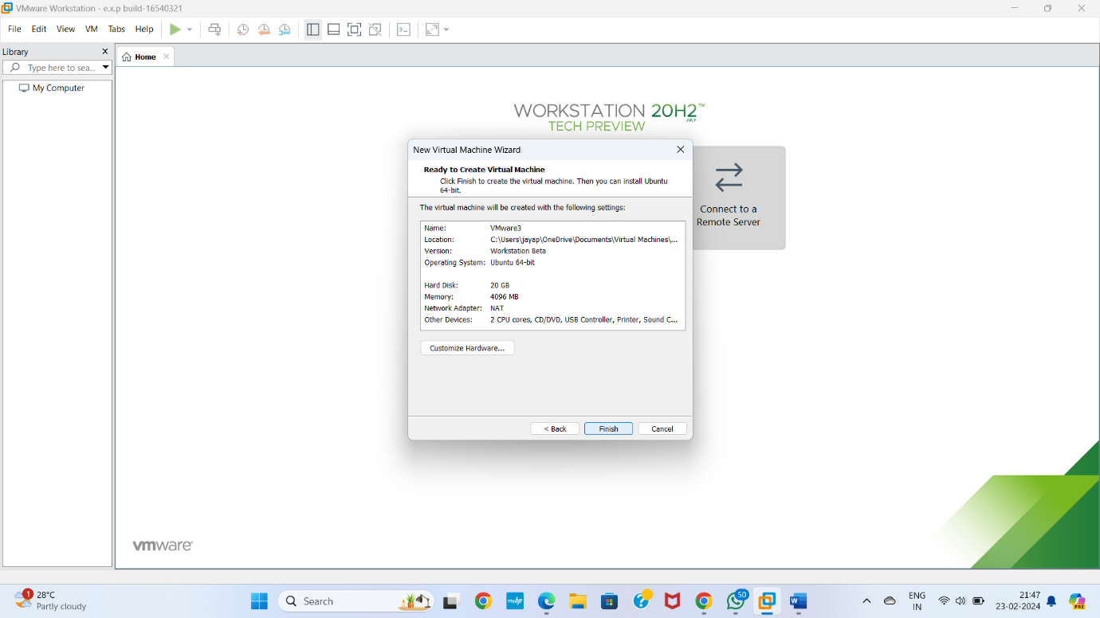

**STEP 8** Created the virtual machine

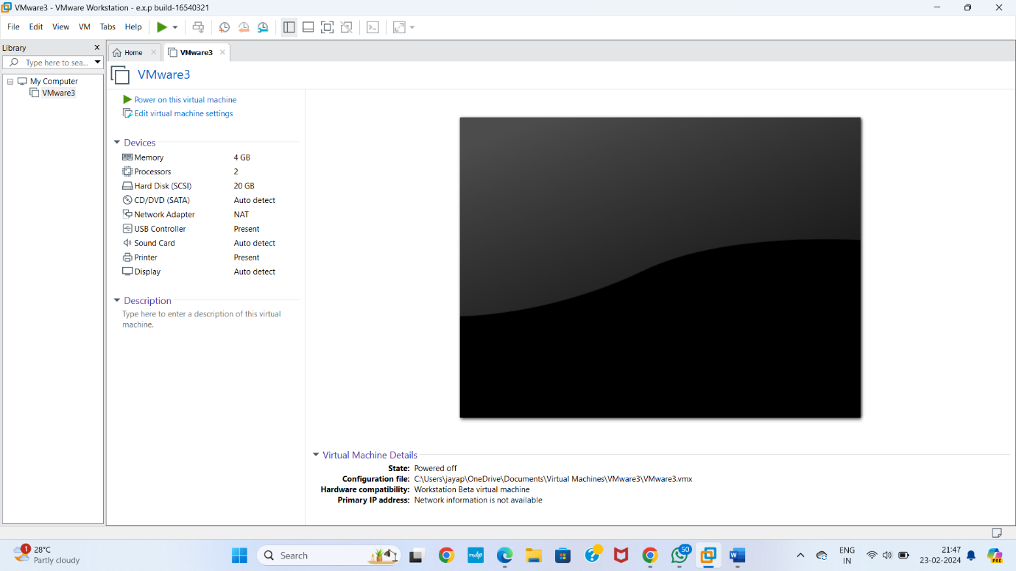

**STEP 9** Select VM

Select option snapshot

In that select Take a snapshot

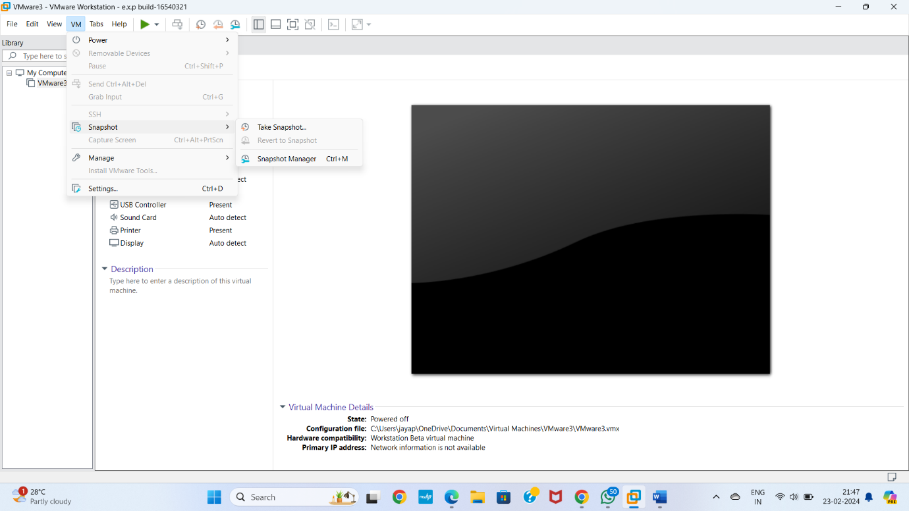

**Step 10** take Snapshot

Give name as 1

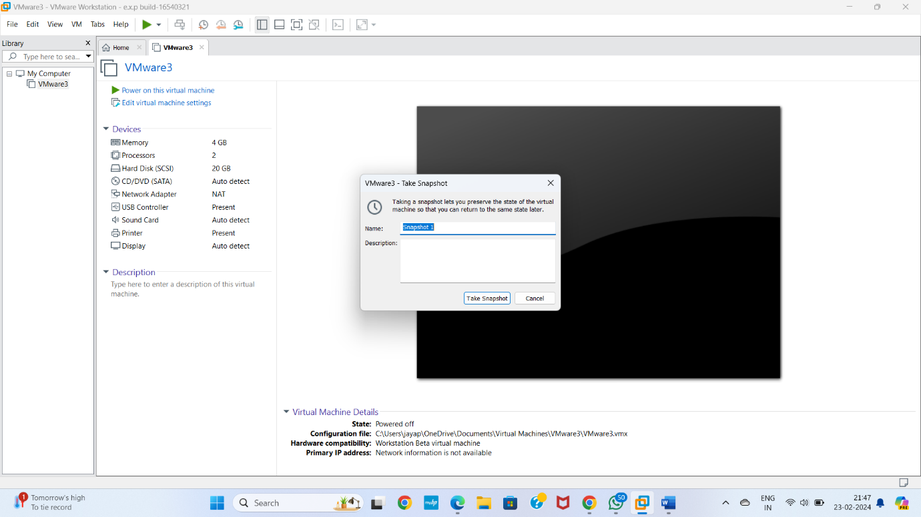

**Step 11** change the values memory

Take a snapshot

Give name as Snapshot 2

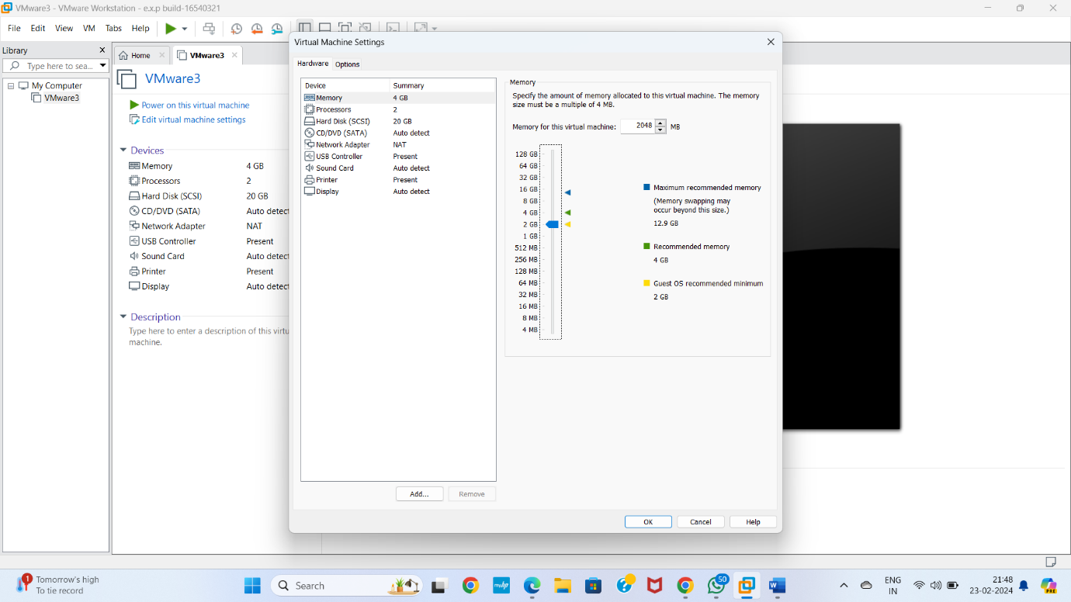

**STEP 12** After chaining the memory value virtual machine

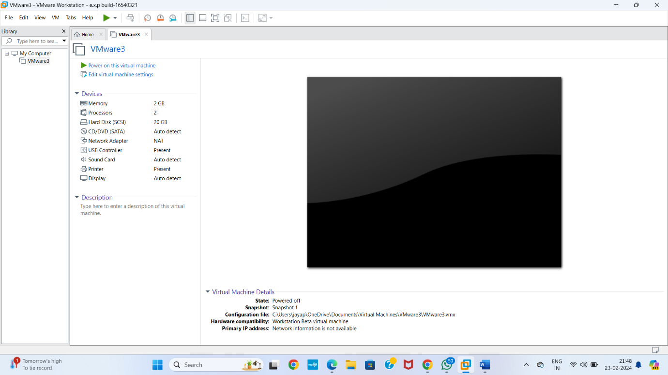

**STPE 13** Take a snapshot

Give name as Snapshot 2

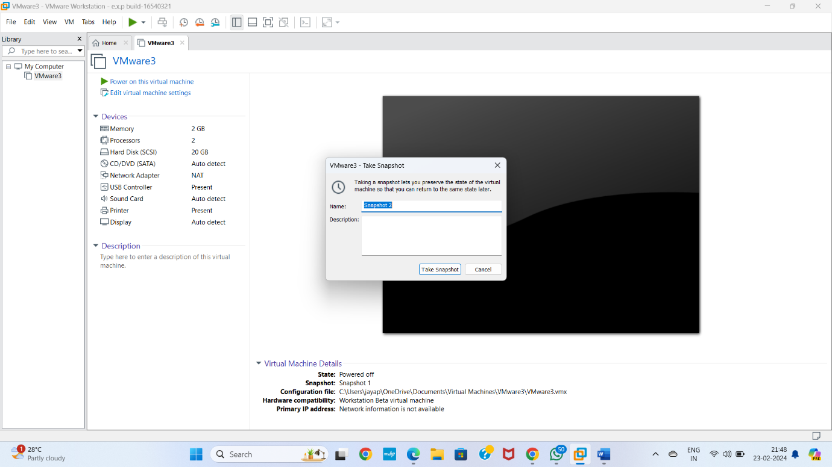

**STEP 14** Chaining the processor value

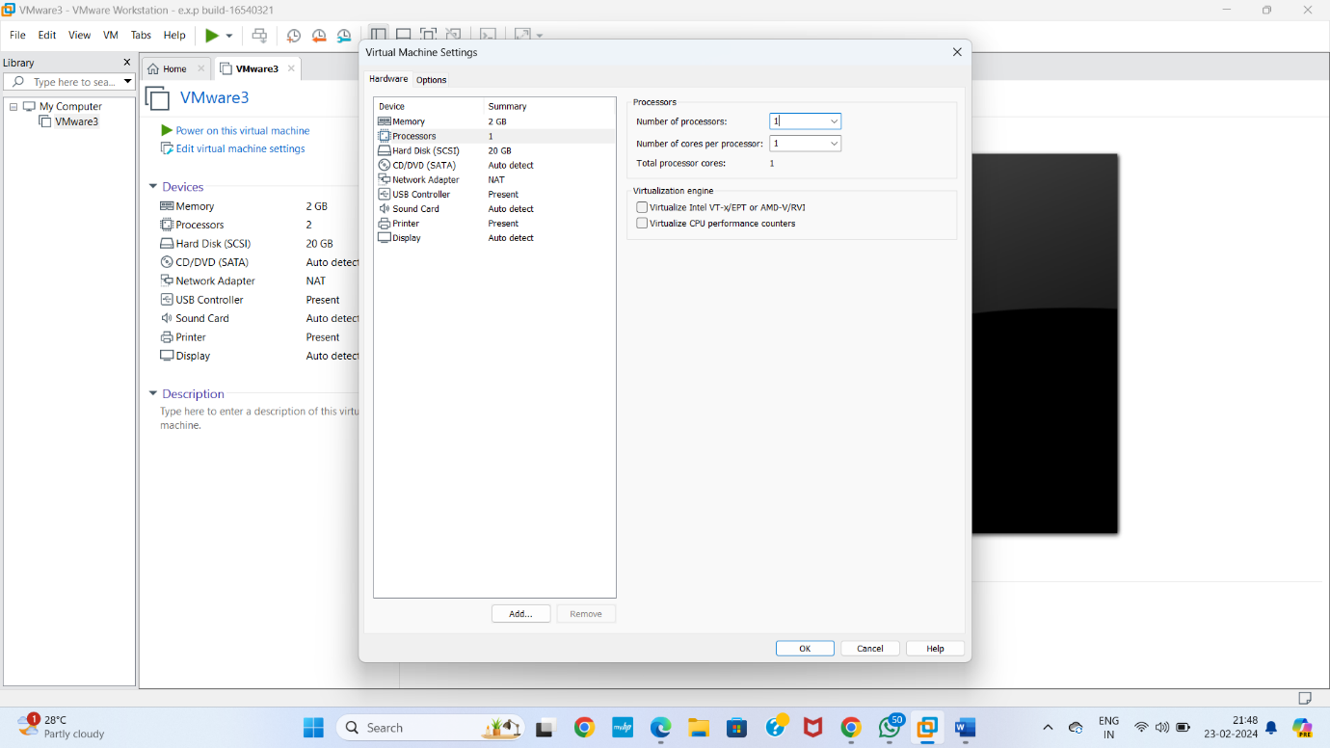

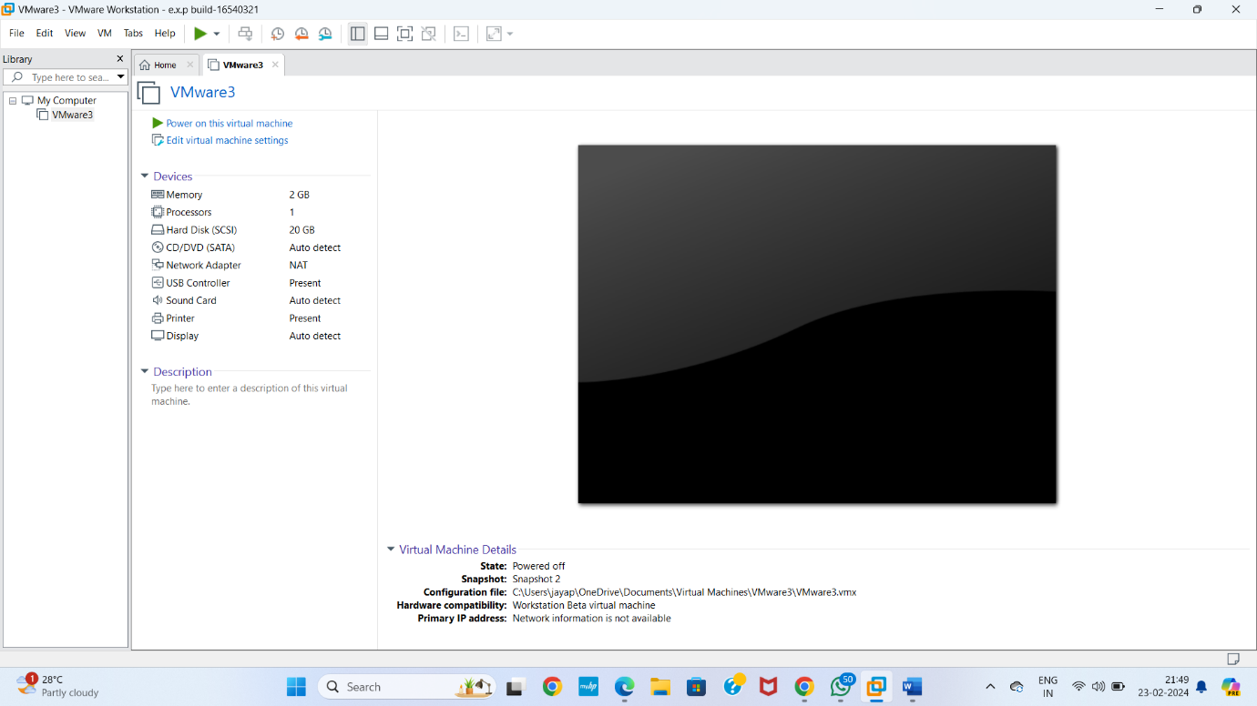

**STEP 15** GOTO VM

Select option snapshot

In that select snapshot manager

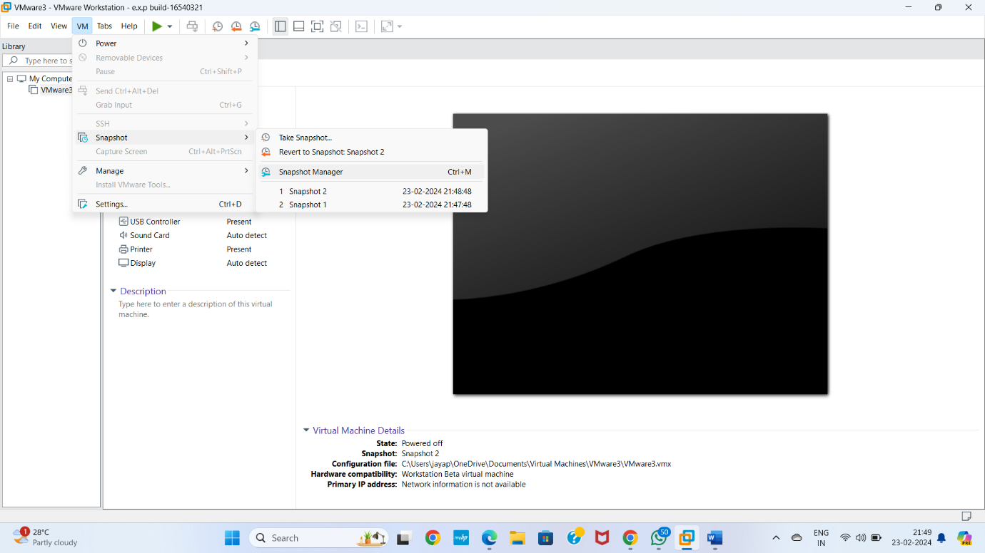

**STEP 16** Snapshot manager

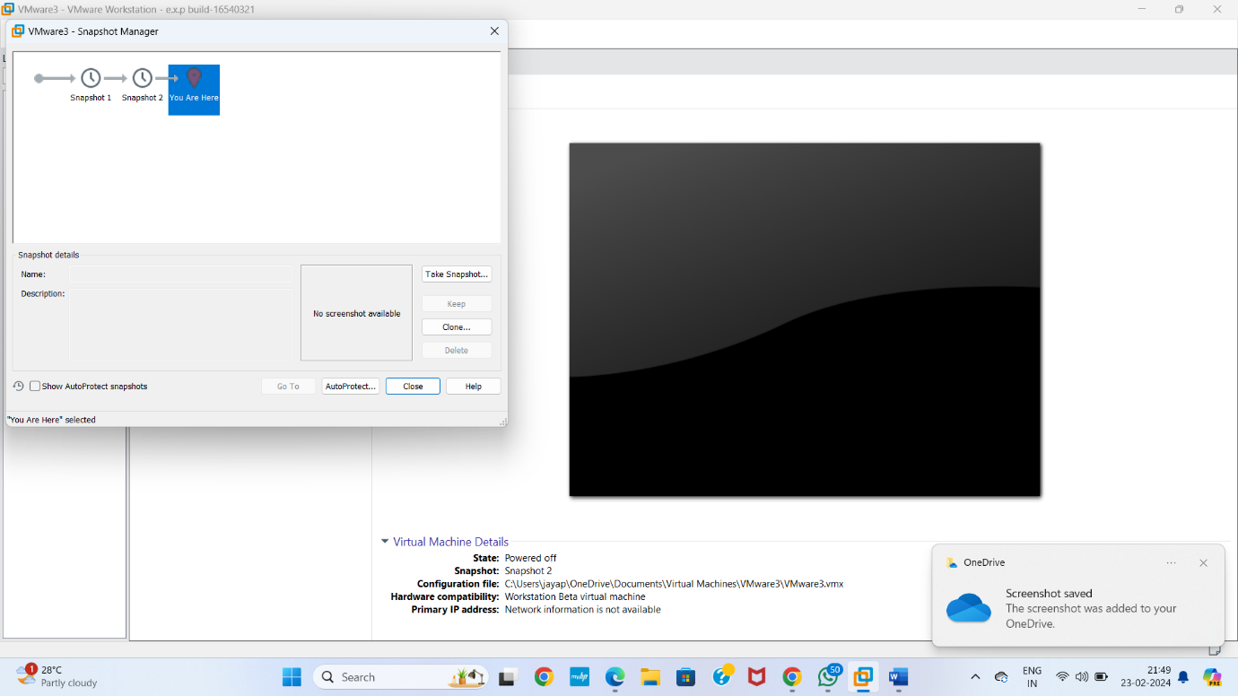

**STEP 17** Select any option snapshot 1 or snapshot 2 or snapshot 3

Select GOTO software go that particular snapshot

Click on yes

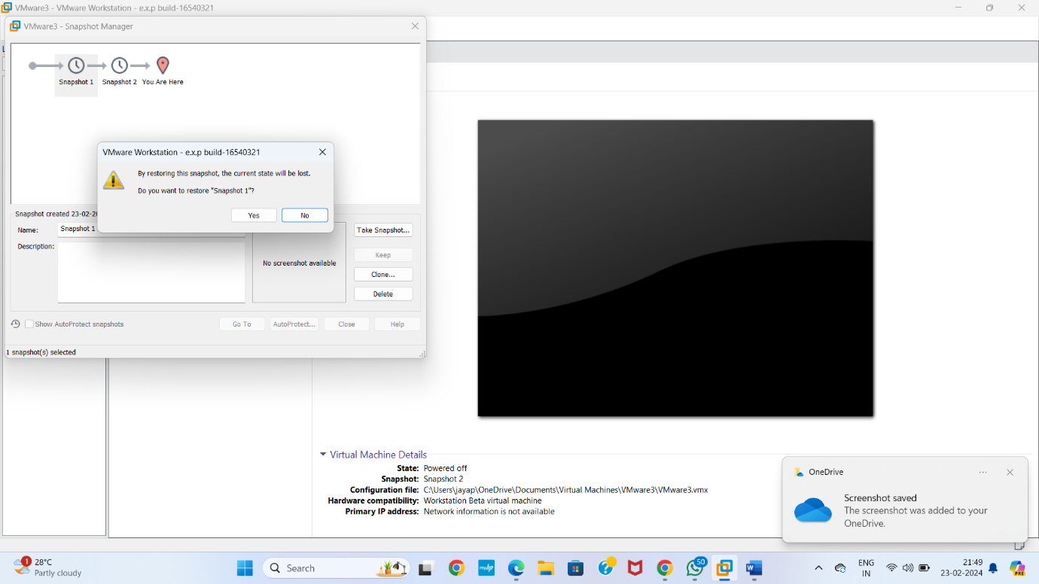

**STEP 18** AS PER THE QUESTION GIVEN SOFTWARE IS DEVEPLOED

